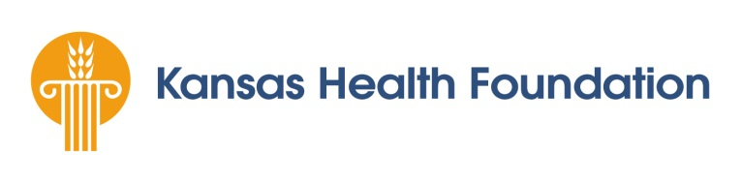

Financial Relationship Statement

Check the statement that most accurately describes the applicant organization’s financial relationships with tobacco companies and soft drink manufacturers. Attach a description of any such financial relationships.

____________ The applicant organization does not accept monetary donations, contributions, sponsorships, in-kind gifts, loan of goods or services under any condition from any tobacco company or soft drink manufacturer.

____________ The applicant organization does accept monetary donations, contributions, sponsorships, in-kind gifts, loan of goods or services under any condition from any tobacco company or soft drink manufacturer. We have attached a description of our relationships.

____________________________________________
Signature

____________________________________________
Title

____________________________________________
Date

A list of tobacco companies can be found at: http://www.hsph.harvard.edu/administrative-offices/faculty-affairs/faculty-appointments/policy-on-tobacco-related-companies/index.html.
Vending machines do not need to be described unless on-site vending is a contractual deliverable between the applicant organization and a soft drink manufacturer.

