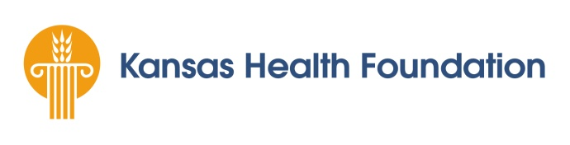
Kansas Integrated Voter Engagement Initiative:
Health Depends on a Vibrant Democracy
Proposal Objectives Template
Objective | Measurement | Timeframe
EXAMPLE Objective: By November 2018, Example A Organization will have hosted five issue forums across the state to raise awareness around criminal justice as a voting issue. | Documentation of the five forums | Year One
EXAMPLE Objective: By May 2018, Example A Organization will have completed an assessment of needed internal infrastructure to effectively do grassroots mobilizing. | Documentation of the assessment | Year One
EXAMPLE Objective: By July 2018, Example A Organization will hire a digital organizer to address staffing gaps needed to effectively mobilize community members. | Documentation of the hire | Year One
EXAMPLE Objective: By November 2019, Example A Organization will conduct a community-wide campaign educating citizens about the mechanics of voting. | Campaign materials | Year Two
EXAMPLE Objective: By November 2019, Example A Organization will have executed a policy issue campaign resulting in 20% of targeted community members contacting a public official. | Survey of targeted community members | Year Two
EXAMPLE Objective: By October 2020, Example A Organization will recruit at least three community members as candidates for public office. | Filing papers | Year Three
EXAMPLE Objective: By November 2020, Example A Organization will increase the number of first-time registered voters by 10% in their priority community. | Documentation of completed registrations | Year Three
Following are example objectives to help applicants put together their own. For more guidance on what to consider when writing objectives, please see the “Objectives” section on page 4 of the RFP.

Kansas Integrated Voter Engagement Initiative:
Health Depends on a Vibrant Democracy
Proposal Objectives Template
Please complete all columns for each objective, adding rows as needed.
Objective | Measurement | Timeframe

